ASSIGNMENT – MACHINE LEARNING
Customer Churn Prediction and Segmentation System
Problem Statement
A service-based company is experiencing customer attrition and wants to use historical customer data to identify customers who are likely to discontinue its services. Develop a machine learning system that predicts customer churn and also groups customers with similar behavioural characteristics to support targeted retention strategies.
Technical Requirements
- Select an appropriate public customer churn dataset and clearly mention its source.
- Perform necessary data preprocessing, including:
  - handling missing values,
  - encoding categorical attributes,
  - removing irrelevant attributes, and
  - feature scaling wherever required.
- Perform suitable exploratory data analysis to understand important characteristics of the dataset.
- Divide the dataset appropriately into training and testing data.
- Implement at least three supervised learning algorithms from the syllabus, such as:
  - Logistic Regression,
  - Naive Bayes,
  - Decision Tree,
  - Support Vector Machine,
  - Neural Network,
  - Bagging, or
  - Boosting.
- Train the selected models to classify customers as Churn / Non-Churn.
- Evaluate the models using suitable performance measures such as:
  - Accuracy,
  - Precision,
  - Recall,
  - F1-score, and
  - Confusion Matrix.
- Compare the performance of the implemented models and identify the best-performing model with suitable justification.
- Apply K-means clustering to group customers based on relevant behavioural or service-related attributes.
- Determine an appropriate number of clusters and interpret the characteristics of the resulting customer groups.
- Apply PCA wherever appropriate to reduce dimensionality or support visualization of customer clusters.
- Provide meaningful visualizations for:
  - important dataset characteristics,
  - classification performance, and
  - customer clusters.
- Use the final results to identify high-risk customer groups and provide suitable retention recommendations.
- The implementation should be executable from beginning to end without errors.
Expected Outcome
The completed system should demonstrate a complete machine-learning workflow from data preprocessing → model training → prediction → model evaluation and selection → customer clustering → interpretation of results.
The selected concepts directly reflect the course emphasis on supervised and unsupervised learning and the course outcome concerning evaluation and model selection.
Assignment Submission Instructions
- This is a team assignment.
- Only one submission per team is required.
- Submit all components in one consolidated document/file.
- The submitted document must include:
  - Pseudocode / workflow of the proposed machine learning solution.
  - Dataset description and source.
  - Data preprocessing steps.
  - Implementation/code.
  - Screenshots of important outputs and visualizations.
  - Performance comparison of the implemented models.
  - Final observations and conclusion.
  - One-page individual contribution write-up from every team member.
- Individual contributions may include:
  - dataset preparation,
  - preprocessing,
  - exploratory analysis,
  - model implementation,
  - hyperparameter experimentation,
  - evaluation,
  - clustering,
  - visualization,
  - testing,
  - documentation, or
  - GitHub management.
- Do not mention student names or register numbers anywhere in the submitted document.
- Plagiarism checking will be enabled.
- The plagiarism/similarity percentage must be below 20%.
- Submissions with 20% or more similarity must be revised and resubmitted.
- Upload the complete working code/project to GitHub.
- The GitHub repository must contain the dataset link/reference, source files, required libraries/dependencies, and all files needed to execute the project.
- Ensure that the submitted implementation is completely tested before final submission.

INTELLIGENT CUSTOMER CHURN RISK PREDICTION AND BEHAVIOURAL SEGMENTATION SYSTEM
ABSTRACT
Customer churn is a major challenge for service-based organizations because losing existing customers can negatively affect revenue, customer relationships, and long-term business growth. Identifying customers who are likely to discontinue a service at an early stage allows organizations to take appropriate retention measures.
This project presents an end-to-end machine learning system for customer churn prediction and behavioural segmentation. A publicly available customer churn dataset is used to analyze customer demographics, service subscriptions, account information, contract characteristics, payment methods, tenure, and billing-related attributes.
The proposed system performs data preprocessing, exploratory data analysis, feature transformation, supervised classification, model evaluation, customer segmentation, dimensionality reduction, and retention-oriented interpretation. Multiple supervised machine learning algorithms are implemented and compared using accuracy, precision, recall, F1-score, and confusion matrices. K-Means clustering is subsequently applied to identify groups of customers with similar behavioural and service characteristics. Principal Component Analysis (PCA) is used to support visualization of the resulting customer segments.
The final system combines churn prediction and customer segmentation to identify high-risk customer groups and associate them with suitable retention strategies. Thus, the proposed solution moves beyond simple churn prediction and provides a decision-support framework for understanding who is likely to churn, what type of customer they are, and what type of intervention may be appropriate.
INTRODUCTION
Customer retention is an important objective for service-oriented organizations. Customers may discontinue their services because of pricing, contract conditions, poor service experience, lack of technical support, changing requirements, or alternative service providers.
Traditional customer management approaches generally treat customers in a similar manner. However, customers have different characteristics, usage patterns, service preferences, contract types, and levels of engagement. Machine learning can help organizations identify hidden patterns within historical customer data and use those patterns to make informed decisions.
The proposed project addresses this problem using two complementary machine learning approaches.
Supervised learning is used to predict whether a customer is likely to churn or remain with the service.
Unsupervised learning is used to group customers according to similarities in their behavioural and service-related characteristics.
The combination of these approaches creates a more informative customer intelligence system. Instead of producing only a binary churn prediction, the system can identify customer segments and analyze the churn behaviour of each segment.
The project follows a complete machine learning workflow:
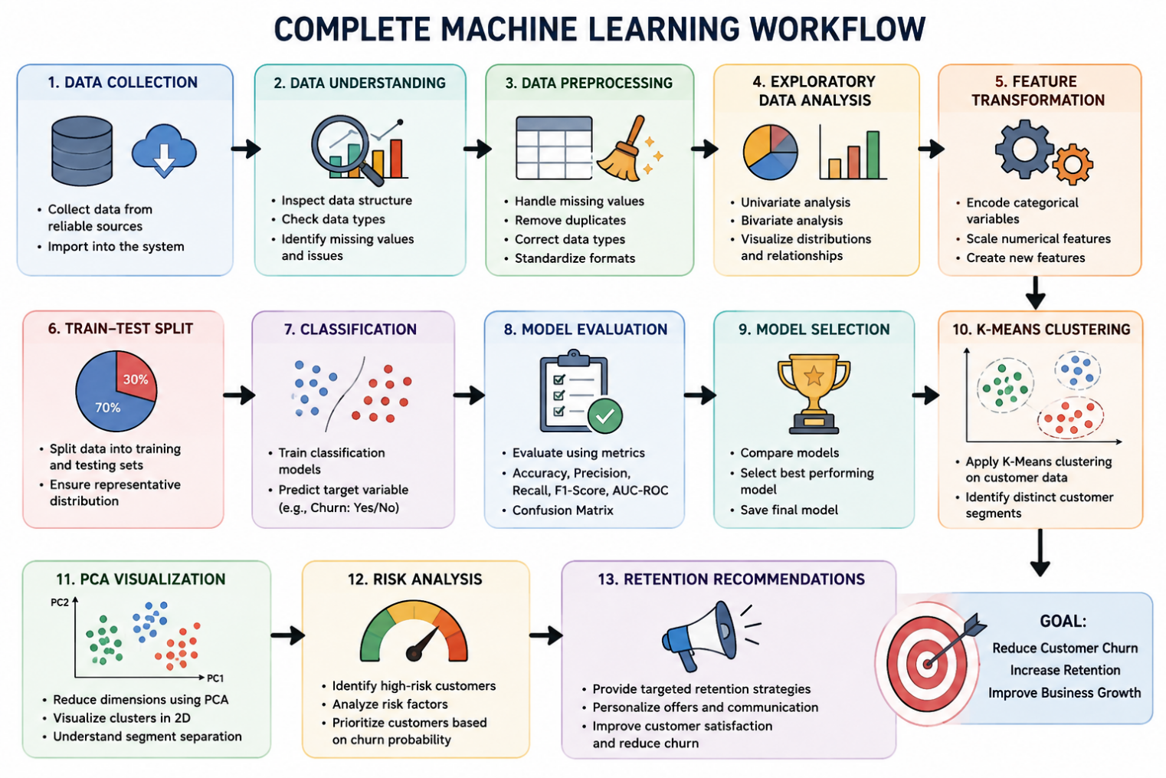
PROBLEM STATEMENT
A service-based company is experiencing customer attrition and wants to use historical customer information to identify customers who are likely to discontinue its services. The objective is to develop a machine learning system that predicts customer churn and groups customers with similar behavioural characteristics so that targeted retention strategies can be developed.
OBJECTIVES
The major objectives of the proposed system are:
- To analyze historical customer information and identify factors associated with churn.
- To preprocess customer data and prepare it for machine learning.
- To perform exploratory data analysis to understand customer behaviour.
- To implement multiple supervised machine learning algorithms for churn classification.
- To evaluate and compare the implemented models using suitable performance metrics.
- To select the most appropriate model based on the evaluation results.
- To apply K-Means clustering to identify behavioural customer segments.
- To determine an appropriate number of clusters using clustering evaluation techniques.
- To apply PCA for dimensionality reduction and cluster visualization where appropriate.
- To identify high-risk customer segments.
- To provide suitable retention recommendations based on customer risk and behavioural characteristics.
- To develop a complete, executable implementation that can be tested from beginning to end.
PROPOSED SYSTEM
The proposed system consists of two major machine learning components.
Churn Prediction Component
The supervised learning component treats churn as a binary classification problem.
The target variable is:
Churn
where:
- 1 / Yes represents a customer who churned.
- 0 / No represents a customer who did not churn.
Multiple classification algorithms are trained using historical customer information. Their predictions are evaluated and compared to determine the most suitable model.
Customer Segmentation Component
The unsupervised learning component uses K-Means clustering to group customers with similar characteristics.
Unlike classification, clustering does not require a predefined target class. Instead, it discovers natural groups within the customer population based on selected behavioural and service-related attributes.
Integrated Decision-Support Component
The final system combines:
Churn Probability + Customer Segment + Segment Churn Rate
to identify customers and groups requiring greater retention attention.
This provides a more practical interpretation of machine learning results.

SYSTEM WORKFLOW
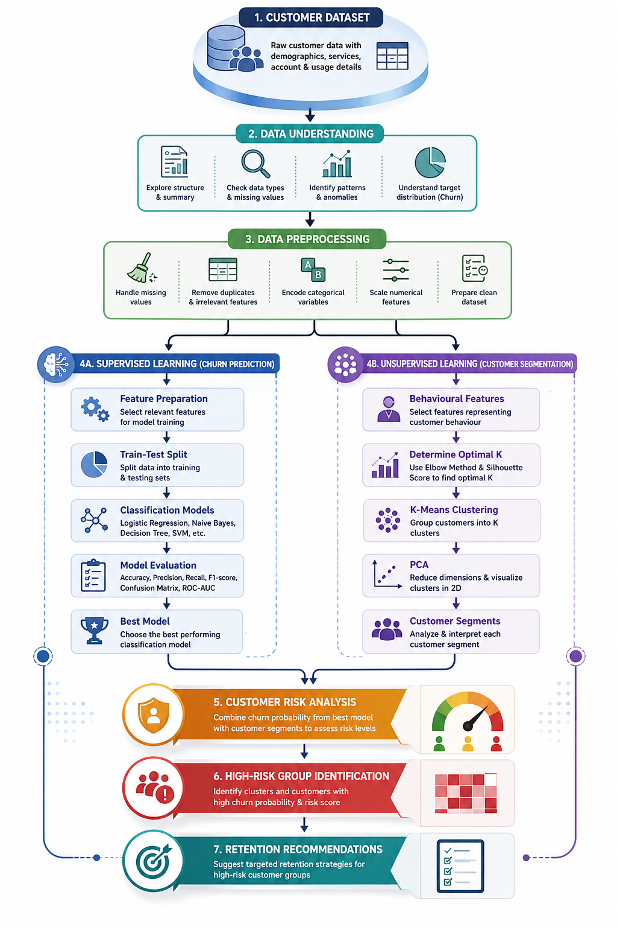
PSEUDOCODE
BEGIN
Load the customer churn dataset
Inspect dataset dimensions, attributes and data types
Identify missing, inconsistent and duplicate values
Remove irrelevant attributes
Convert numerical attributes into appropriate numeric format
Handle missing values
Encode categorical attributes
Separate input features and churn target
Apply feature scaling where required
Split the dataset into training and testing sets
Initialize selected supervised learning algorithms
FOR each classification model
Train the model using the training dataset
Generate churn predictions for test data
Calculate accuracy
Calculate precision
Calculate recall
Calculate F1-score
Generate confusion matrix
END FOR
Compare classification models
Select the most suitable model
Use the selected model to estimate customer churn probability
Prepare relevant behavioural attributes for clustering
Test different numbers of clusters
Apply Elbow Method
Calculate Silhouette Scores
Select an appropriate number of clusters
Apply K-Means clustering
Calculate characteristics of each cluster
Calculate churn rate for each cluster
Apply PCA when required for dimensionality reduction
Generate cluster visualization
Identify high-risk customer segments
Combine churn risk and cluster characteristics
Generate suitable retention recommendations
Display final results and visualizations
END
DATASET DESCRIPTION
Dataset Link: https://www.kaggle.com/datasets/blastchar/telco-customer-churn
Dataset: Telco Customer Churn
Source: Kaggle
Original Source: IBM Sample Data Sets
Records: 7,043 customers
Attributes: 21 columns
Target Variable: Churn
The project uses a publicly available Telco Customer Churn dataset.
The dataset contains historical customer-level information associated with telecommunications services. It includes customer demographic information, subscribed services, account information, contract details, billing information, payment methods, and churn status.
Important attributes include:
- Customer identifier
- Gender
- Senior citizen status
- Partner status
- Dependents
- Tenure
- Phone service
- Multiple lines
- Internet service
- Online security
- Online backup
- Device protection
- Technical support
- Streaming services
- Contract type
- Paperless billing
- Payment method
- Monthly charges
- Total charges
- Churn status
Target Variable
The target variable is Churn.
It represents whether the customer discontinued the service.
The target is transformed into a binary representation suitable for classification algorithms.
Dataset Source
The dataset source and access reference should be clearly mentioned in the final document and in the GitHub repository. The assignment specifically requires a public customer churn dataset with its source clearly identified.
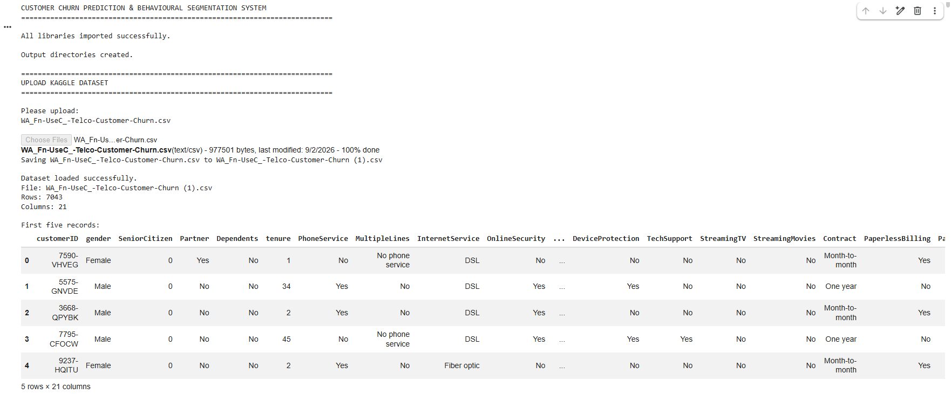
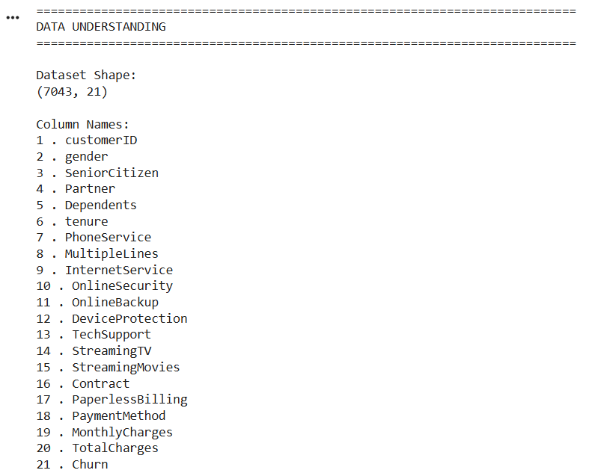
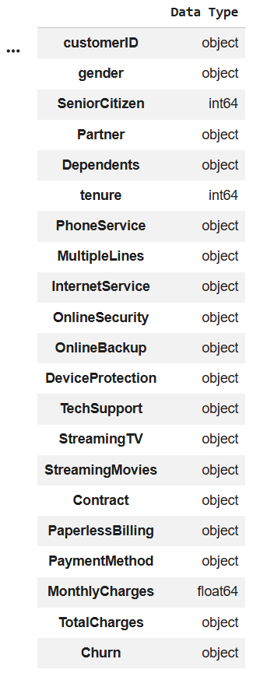
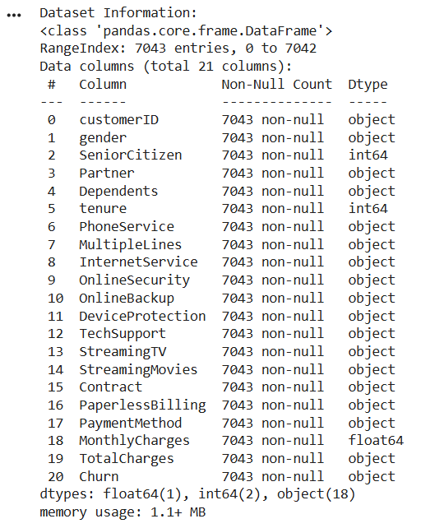
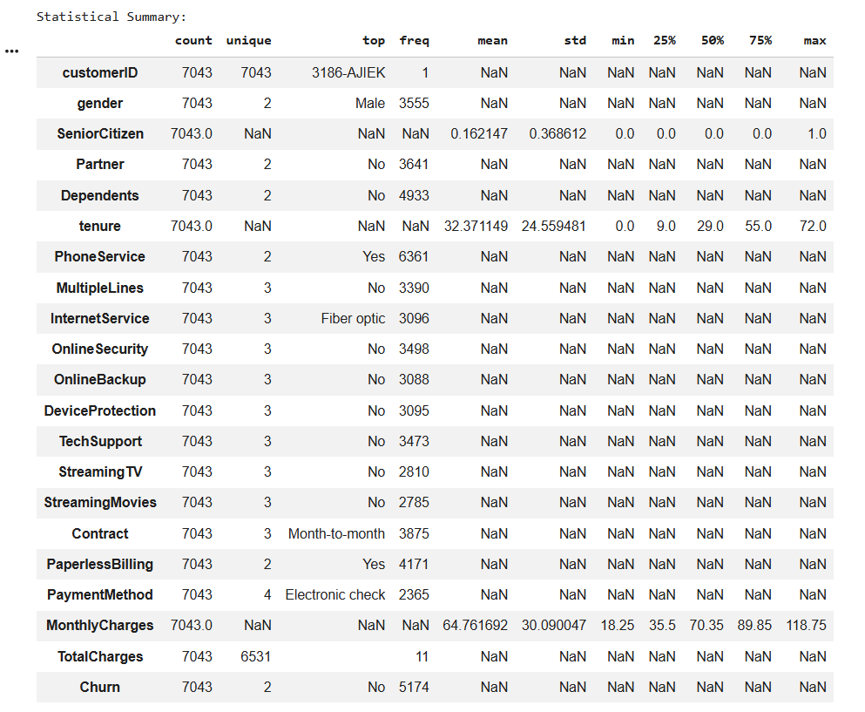
DATA PREPROCESSING
Raw customer data cannot be directly supplied to all machine learning algorithms. Therefore, several preprocessing operations are performed.
Data Inspection
The dataset is first examined to determine:
- Number of records
- Number of attributes
- Data types
- Missing values
- Duplicate records
- Unique values
- Distribution of the target variable
This provides an understanding of the quality and structure of the dataset.
Removal of Irrelevant Attributes
The customer identification attribute is removed because it uniquely identifies a customer but does not represent meaningful behavioural information.
For example:
customerID
is not used as a predictive feature.
Missing Value Handling
Missing values are identified using null-value analysis.
Some numerical fields may contain blank values rather than conventional missing-value indicators. Such fields are converted into appropriate numeric types and missing observations are handled using a suitable strategy.
Data Type Conversion
Attributes representing numerical quantities are converted into numeric data types.
For example:
TotalCharges
is converted from text representation into a numerical format.
Categorical Encoding
Machine learning algorithms require numerical representations of categorical attributes.
Binary attributes are transformed into numerical values where appropriate.
Multi-category variables such as contract type, internet service and payment method are transformed using one-hot encoding.
Feature Scaling
Numerical features are standardized using a scaling technique such as StandardScaler.
Scaling is particularly important for algorithms such as:
- Support Vector Machine
- K-Means
- PCA
because these methods can be influenced by differences in feature magnitude.
Train-Test Split
The preprocessed dataset is divided into training and testing subsets.
A stratified split can be used so that the proportion of churn and non-churn customers remains approximately consistent across both subsets.

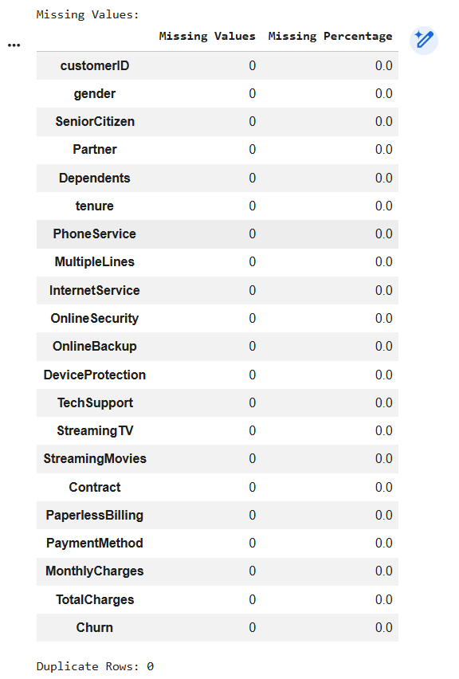
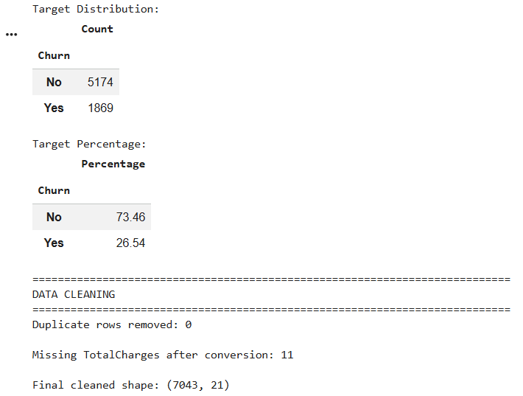
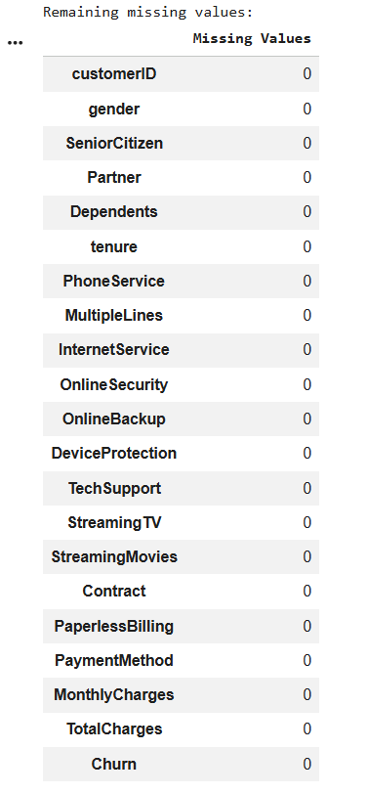

EXPLORATORY DATA ANALYSIS
Exploratory Data Analysis is performed before model development to understand relationships within the dataset and identify characteristics associated with customer churn.
The following visualizations should be included in the final report.
Churn Distribution
A count plot showing the number of:
- Churned customers
- Non-churned customers
This helps determine the overall churn distribution and whether class imbalance is present.
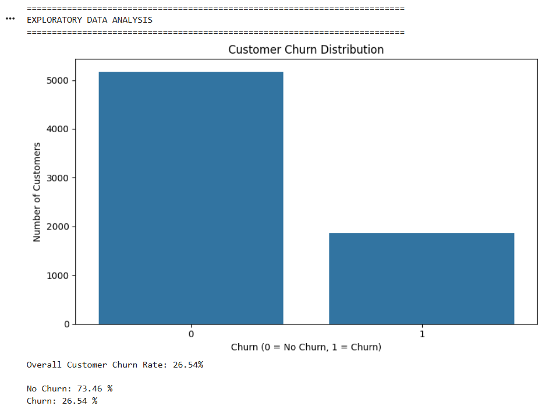
Churn by Contract Type
Customers are grouped according to contract type and their churn rates are compared.
This helps determine whether contractual commitment is associated with customer retention.
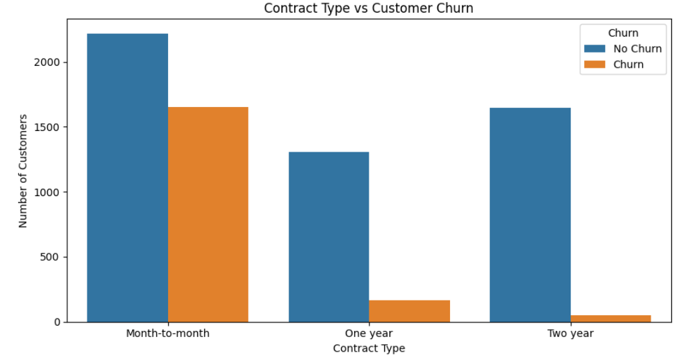
Tenure Distribution
Tenure is analyzed with respect to churn.
The analysis helps identify whether customers with shorter or longer relationships with the company demonstrate different churn patterns.
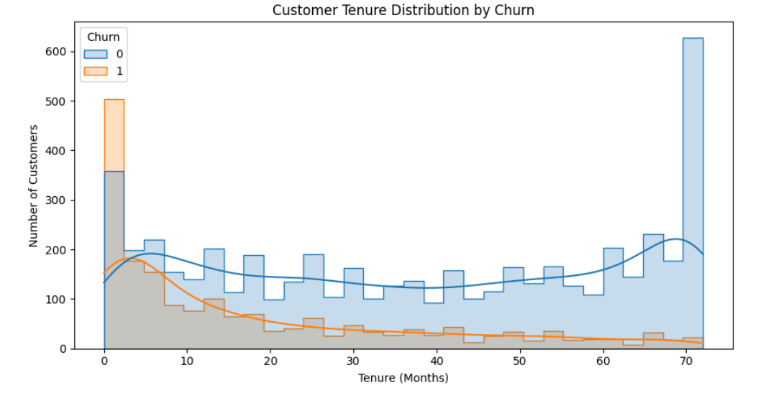
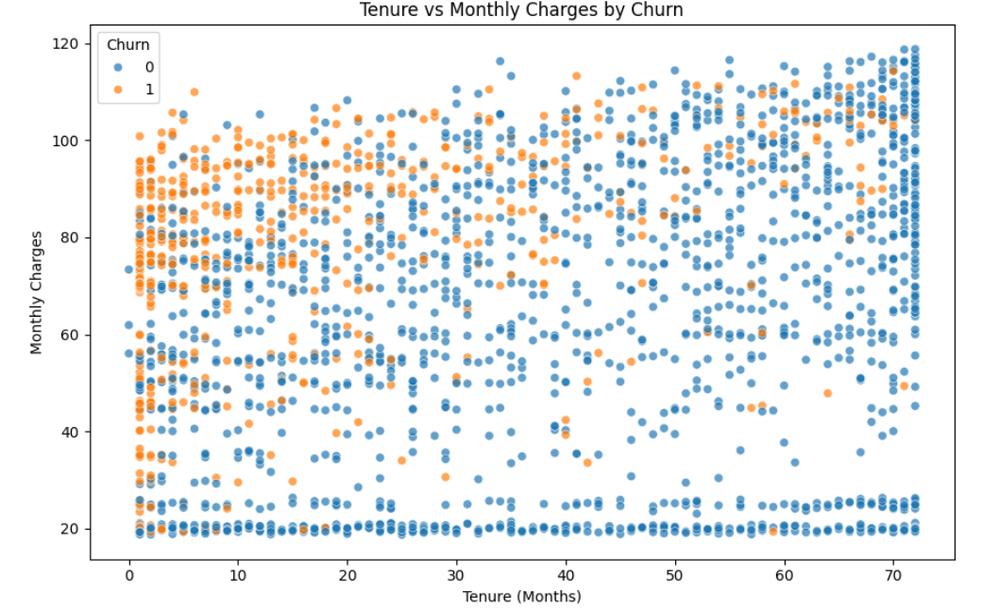
Monthly Charges and Churn
Monthly charges are compared between churned and non-churned customers.
This can help determine whether pricing or billing level may be associated with customer attrition.
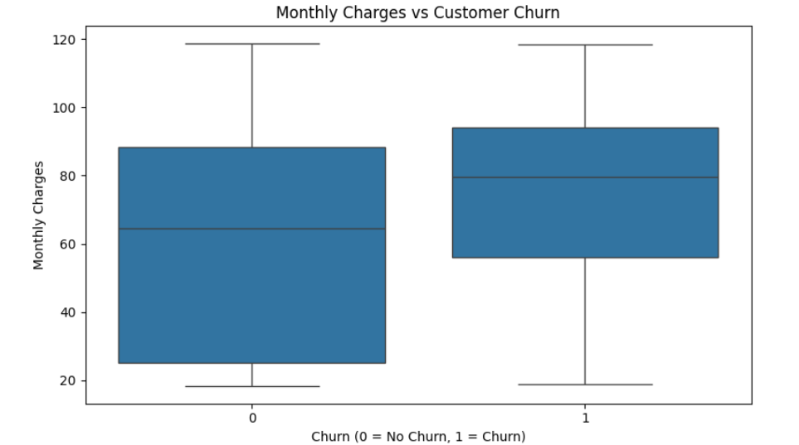
Payment Method and Churn
Customer churn is analyzed across different payment methods.
This may reveal behavioural differences among customer groups.
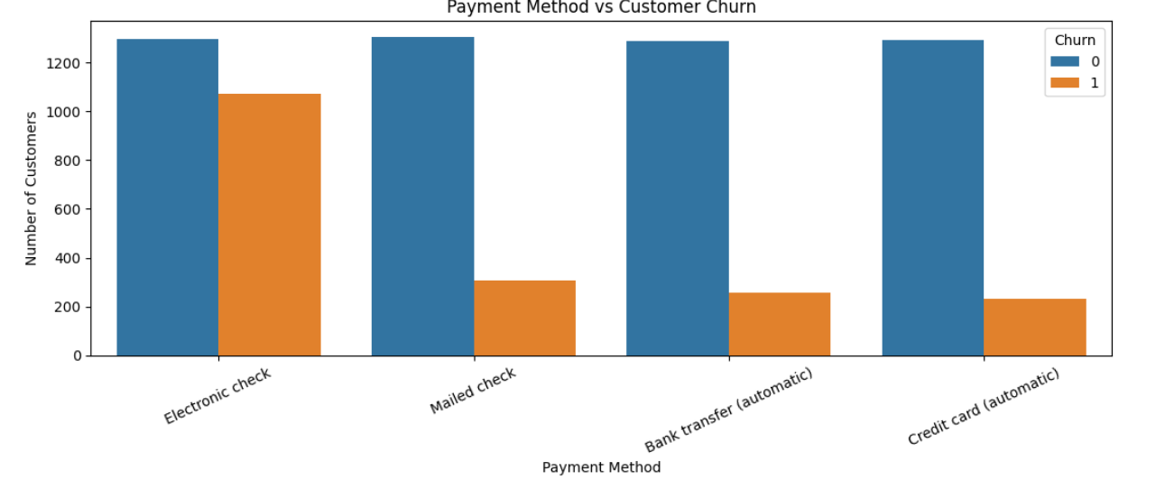
Service Subscription and Churn
Internet service, technical support, online security and related services can be analyzed to identify service-related patterns associated with churn.
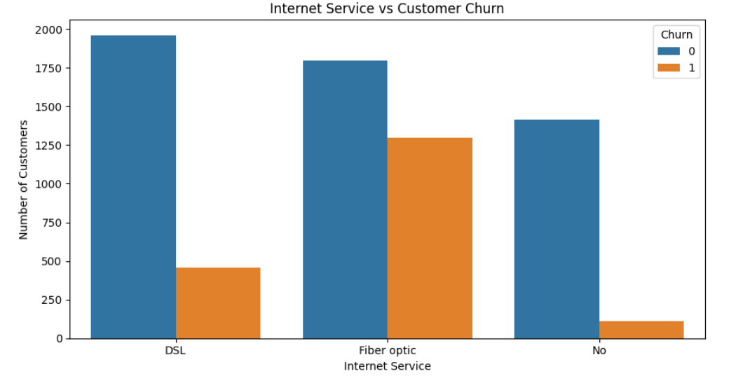
Correlation Analysis
A correlation heatmap can be generated for suitable numerical attributes to identify relationships among important variables.
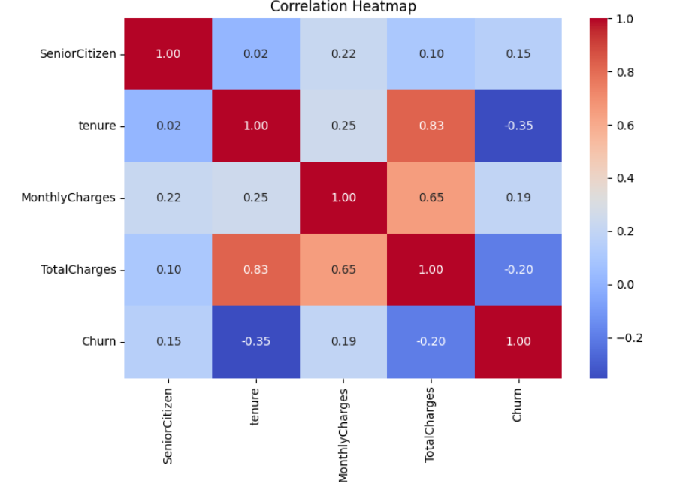
MACHINE LEARNING MODELS
The assignment requires at least three supervised learning algorithms.
The proposed implementation can use the following models.

Logistic Regression
Logistic Regression is used as an interpretable baseline classification algorithm.
It estimates the probability that a customer belongs to the churn class.
The model is particularly useful because it provides probability-based predictions and allows the effect of input features to be analyzed.

Naive Bayes
Naive Bayes is a probabilistic classification technique based on Bayes' theorem.
It assumes conditional independence between features given the target class.
It provides a computationally efficient comparison against other classification approaches.

Decision Tree
Decision Tree classification uses a sequence of feature-based decisions to divide customers into different classes.
The model is easy to interpret because its decisions can be represented as a tree structure.

Support Vector Machine
Support Vector Machine attempts to identify an optimal decision boundary separating churn and non-churn customers.
Because SVM is sensitive to feature scale, standardized input features are used.
MODEL TRAINING
The dataset is divided into:
Training Data
Used to learn patterns from historical customer records.
Testing Data
Used to evaluate how well the trained model performs on previously unseen customer records.
The models are trained using the same training and testing framework to ensure a fair comparison.
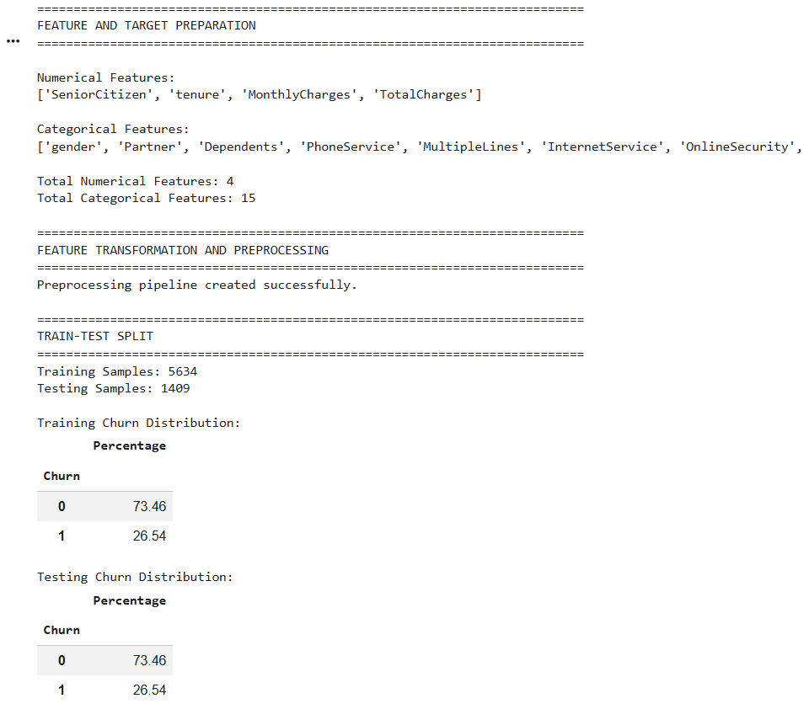
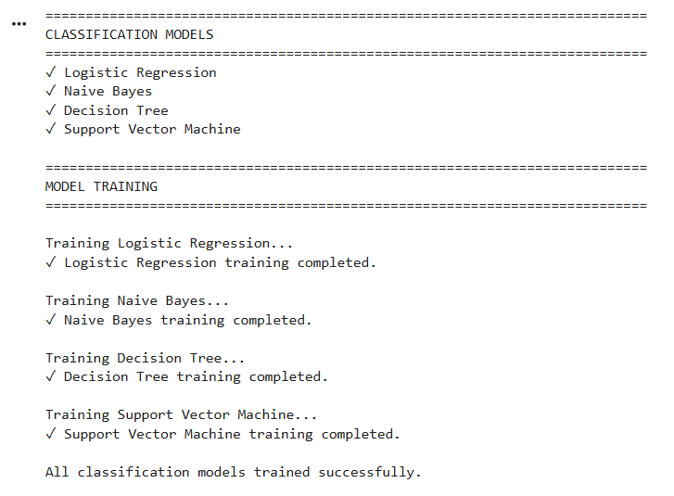
HYPERPARAMETER EXPERIMENTATION
Selected model parameters can be varied to study their influence on classification performance.
For example, Decision Tree experiments can compare different values of maximum tree depth.
SVM experiments can compare different values of the regularization parameter C.
Logistic Regression can also be evaluated using different regularization strengths.
The final parameters should be selected based on the actual experimental results obtained during implementation.
A table such as the following can be included:
Model | Parameter | Values Tested | Selected Value
Logistic Regression | C | 0.1, 1, 10 | Actual result
Decision Tree | max_depth | 3, 5, 8, 10 | Actual result
SVM | C | 0.1, 1, 10 | Actual result
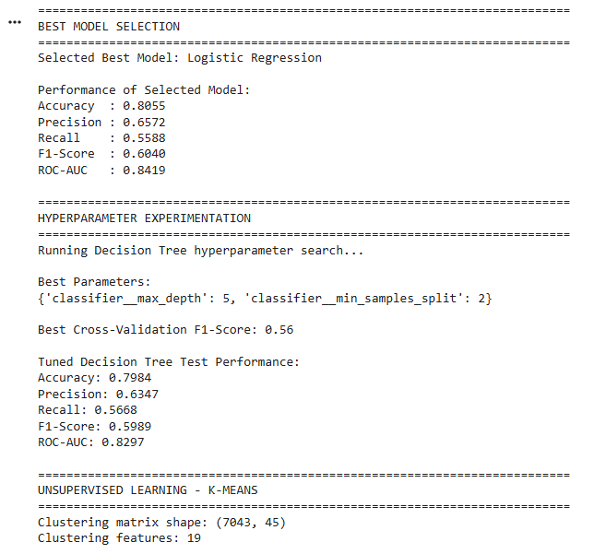
MODEL EVALUATION
The implemented classification models are evaluated using multiple performance measures rather than relying only on accuracy.
Accuracy
Accuracy represents the proportion of correctly classified customers among all tested customers.
Precision
Precision measures how many customers predicted as churners were actually churners.
Recall
Recall measures how many of the actual churners were successfully identified by the model.
Recall is particularly important in a churn prediction problem because failing to identify an actual churner may result in a missed retention opportunity.
F1-Score
F1-score combines precision and recall into a single metric and is useful when both types of performance need to be considered.
Confusion Matrix
The confusion matrix provides the number of:
- True Positives
- True Negatives
- False Positives
- False Negatives
for each model.
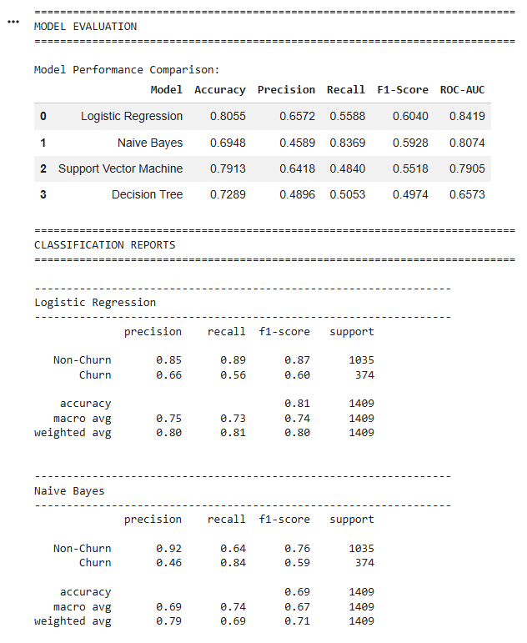
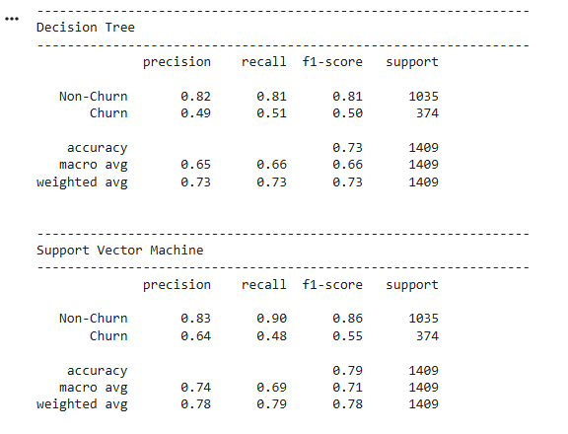
ROC-AUC
If implemented, ROC-AUC can additionally be used to evaluate how effectively a model separates churners from non-churners across different classification thresholds.
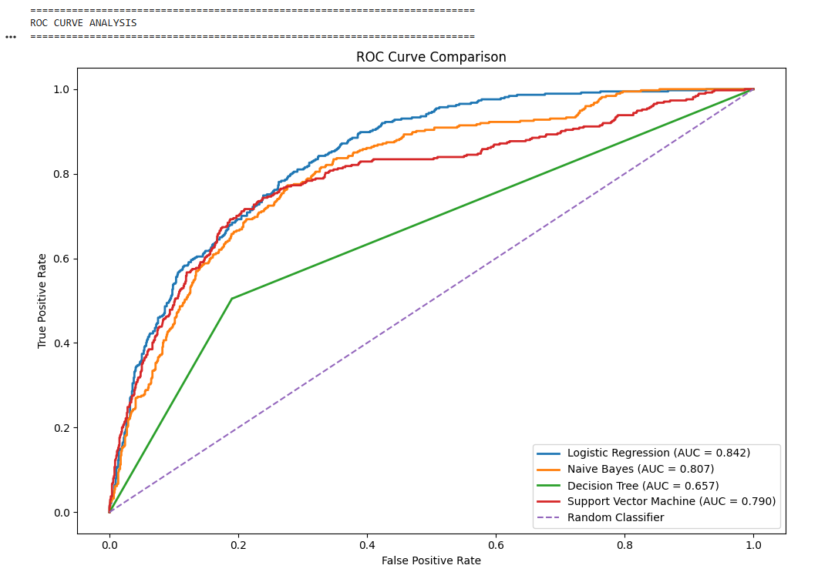
PERFORMANCE COMPARISON OF IMPLEMENTED MODELS
The final results should be presented in a comparison table generated from the actual implementation.
Model | Accuracy | Precision | Recall | F1-Score | ROC-AUC
Logistic Regression | Actual | Actual | Actual | Actual | Actual
Naive Bayes | Actual | Actual | Actual | Actual | Actual
Decision Tree | Actual | Actual | Actual | Actual | Actual
SVM | Actual | Actual | Actual | Actual | Actual
A comparative bar chart should also be included.
The best-performing model should be selected based on the project objective rather than simply choosing the highest accuracy.
For customer churn prediction, recall and F1-score for the churn class should receive particular consideration because identifying actual churners is an important objective.
CONFUSION MATRIX ANALYSIS
A confusion matrix is generated for each classification model.
The matrix consists of:
 | Predicted Non-Churn | Predicted Churn
Actual Non-Churn | True Negative | False Positive
Actual Churn | False Negative | True Positive
A lower number of false negatives is desirable in a churn prediction application because false negatives represent customers who actually churned but were not identified by the system.
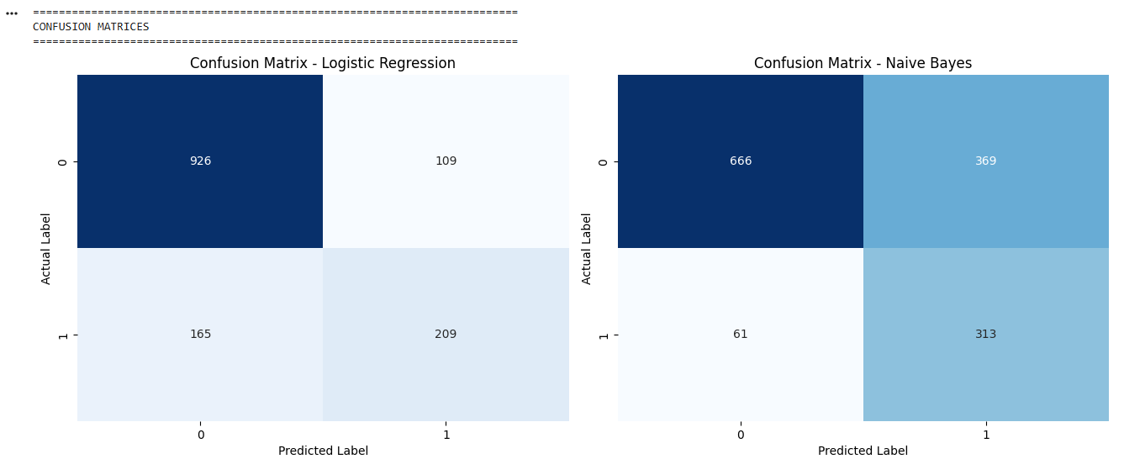
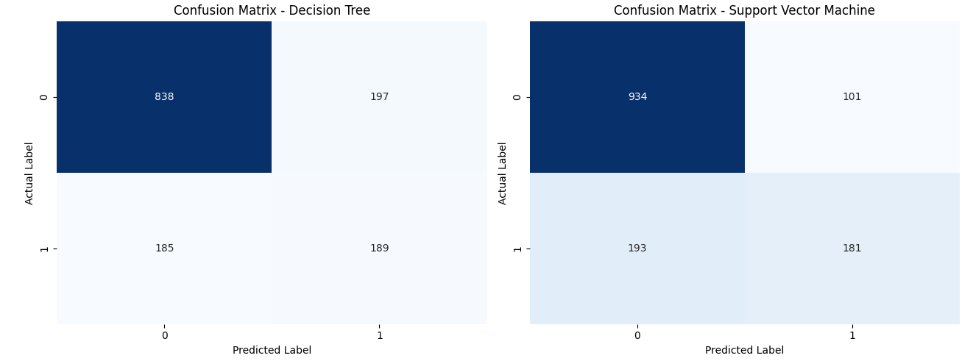
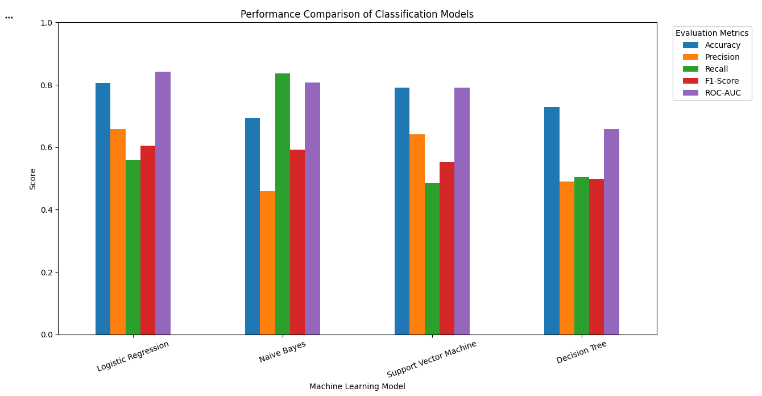
CUSTOMER CHURN RISK SCORE
An additional decision-support layer can be introduced after selecting the best-performing model.
Instead of providing only a binary prediction, the system can use the predicted churn probability to categorize customers into risk levels.
Example:
Churn Probability | Risk Level
Below 0.30 | Low
0.30–0.60 | Medium
Above 0.60 | High
The thresholds should be treated as configurable values and can be adjusted according to the actual project requirements.
This allows the system to produce results such as:
Customer | Churn Probability | Risk
Customer A | Actual | High
Customer B | Actual | Medium
Customer C | Actual | Low
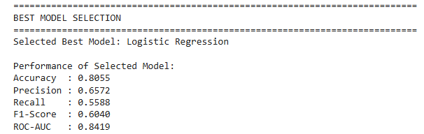
K-MEANS CUSTOMER SEGMENTATION
K-Means clustering is used to divide customers into groups based on similarities in their selected behavioural and service-related characteristics.
The clustering process does not use the churn label as the clustering target. Instead, customer attributes are used to discover naturally occurring customer groups.
Potential clustering attributes include:
- Tenure
- Monthly charges
- Total charges
- Service subscriptions
- Contract characteristics
- Other suitable numerical representations of customer behaviour
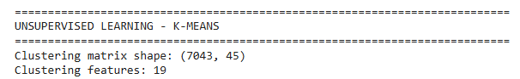
DETERMINING THE NUMBER OF CLUSTERS
An appropriate value of K is determined before applying the final K-Means model.
Elbow Method
K-Means models are trained using different values of K.
The within-cluster sum of squares is plotted against the number of clusters.
The point at which the reduction in within-cluster variation begins to slow down can be considered an appropriate candidate for K.
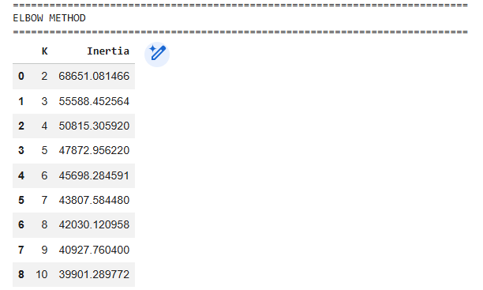
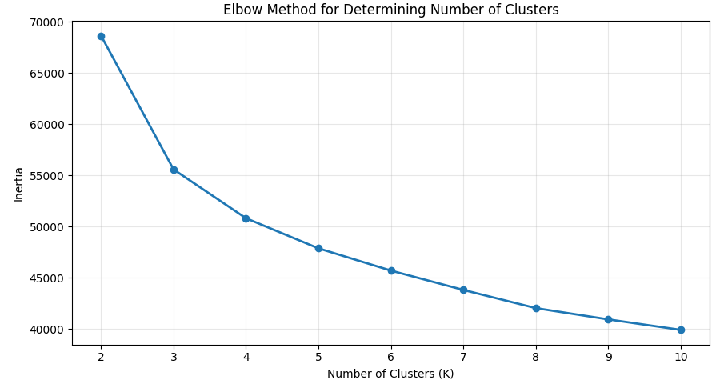
Silhouette Score
Silhouette scores are calculated for different cluster counts.
A higher score generally indicates better separation and cohesion of clusters.
The final cluster count should be selected by considering:
- Elbow Method
- Silhouette Score
- Cluster interpretability
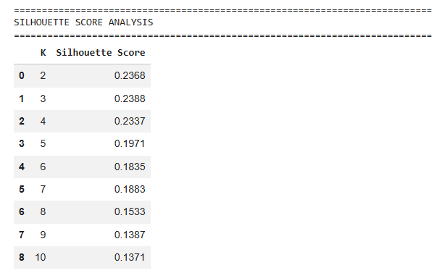

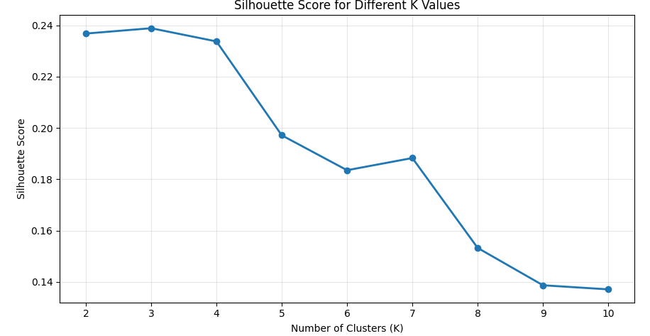
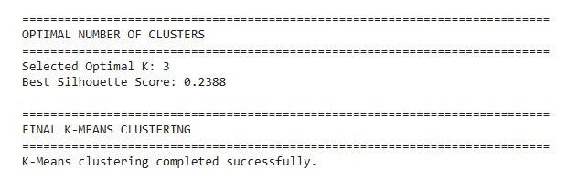
CUSTOMER SEGMENT INTERPRETATION
After clustering, descriptive statistics are calculated for each cluster.
For every cluster, the following can be analyzed:
- Number of customers
- Average tenure
- Average monthly charges
- Average total charges
- Contract distribution
- Service characteristics
- Churn percentage
The clusters should then be assigned meaningful descriptive names based on the actual observed characteristics.
For example:
Long-Term Loyal Customers
May contain customers with relatively long tenure and stable service relationships.
New or Short-Tenure Customers
May contain customers who have recently joined the service and may require stronger early-stage engagement.
High-Charge Customers
May represent customers with relatively high monthly charges and potentially greater price sensitivity.
High-Risk Behavioural Segment
May represent a segment with a comparatively high churn rate.
These labels should be finalized only after examining the actual clustering results.
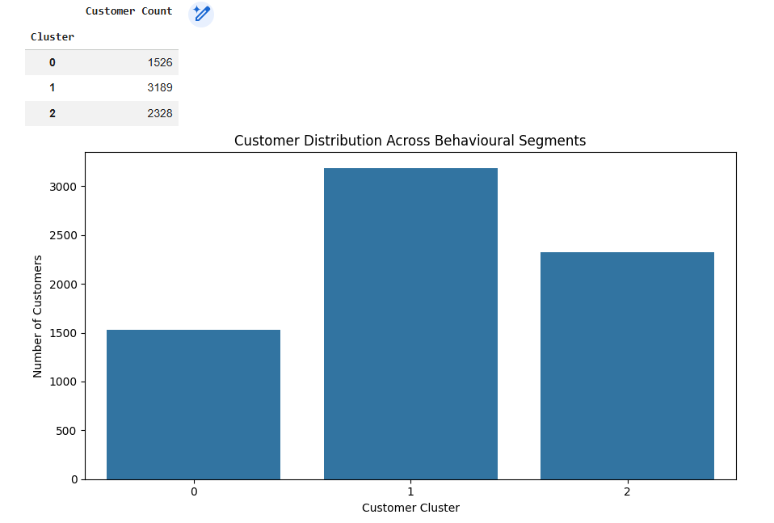
CHURN RATE BY CUSTOMER SEGMENT
One of the important outputs of the project is the comparison of churn rates across clusters.
Cluster | Customer Count | Churned Customers | Churn Rate
Cluster 0 | Actual | Actual | Actual
Cluster 1 | Actual | Actual | Actual
Cluster 2 | Actual | Actual | Actual
Cluster 3 | Actual | Actual | Actual
This analysis connects unsupervised learning with the original churn problem.
A cluster containing a disproportionately high percentage of churned customers can be considered a priority segment for retention analysis.
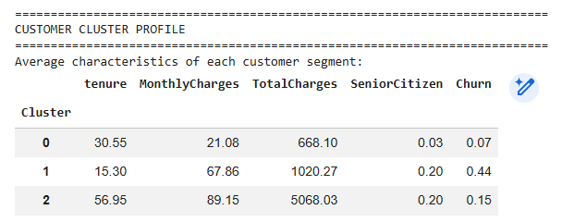
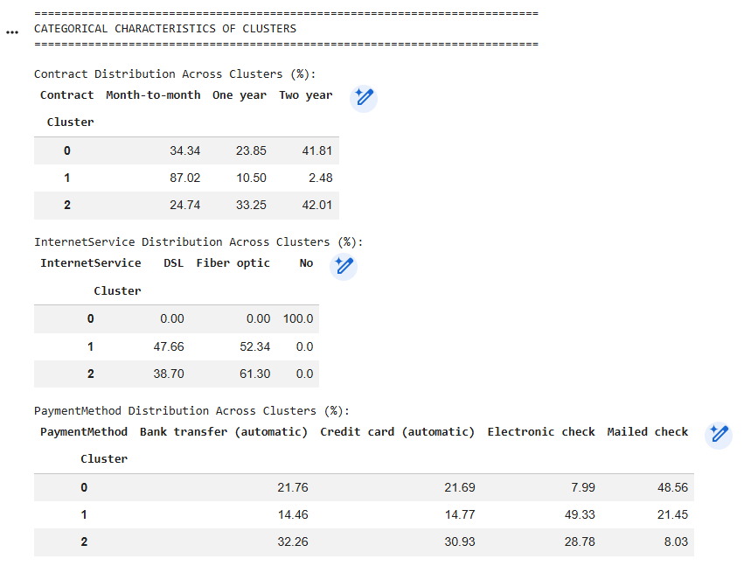
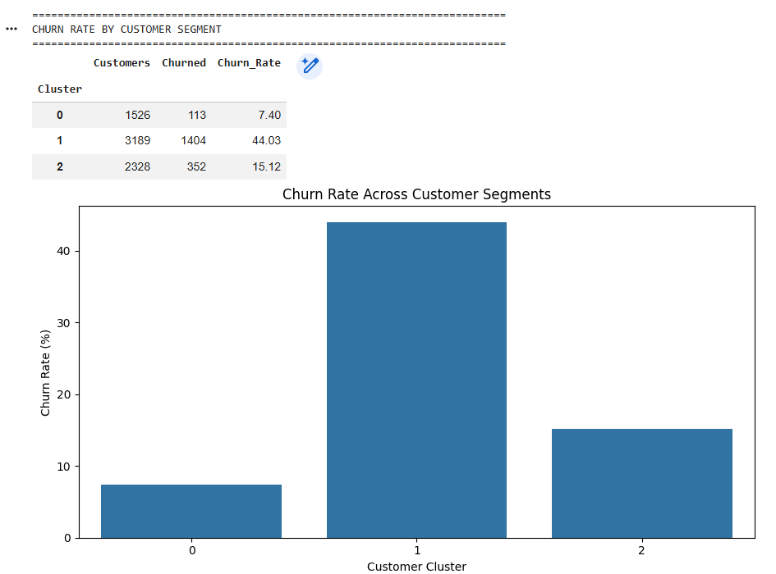
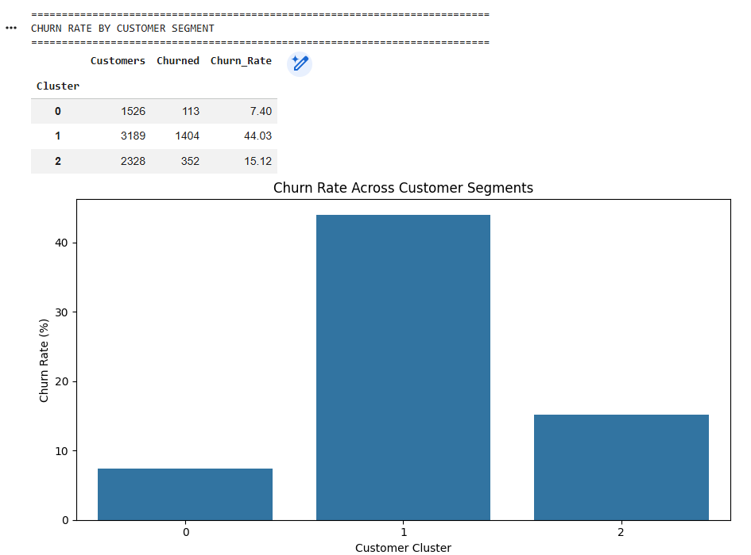
PCA-BASED CUSTOMER SEGMENT VISUALIZATION
After preprocessing and feature transformation, the dataset may contain a large number of dimensions, especially after categorical encoding.
Principal Component Analysis can be used to transform the high-dimensional feature space into a smaller number of components.
The first two principal components can then be plotted to visually examine customer clusters.
The visualization should contain:
- PC1 on the horizontal axis
- PC2 on the vertical axis
- Cluster membership represented using different visual markers/colours
The PCA plot provides an intuitive representation of the degree to which the identified customer groups are separated in the transformed feature space.
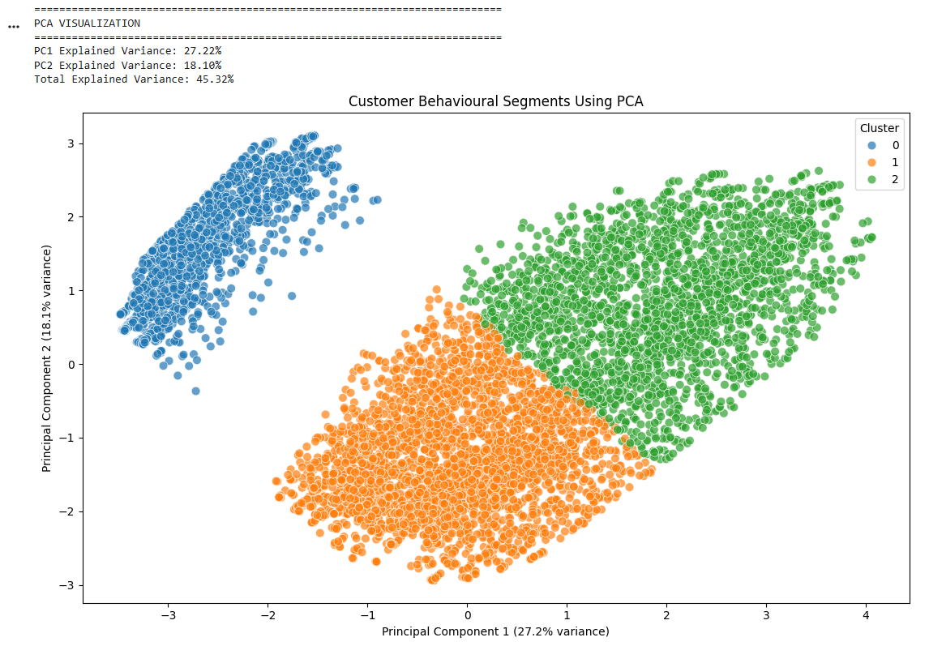
INTEGRATED CUSTOMER RISK AND SEGMENT ANALYSIS
The key proposed feature of the system is the combination of classification and clustering results.
For each customer, the system can provide:
Customer Profile
↓
Churn Probability
↓
Risk Category
↓
Behavioural Segment
↓
Recommended Retention Strategy
Example output:
Customer | Risk | Segment | Recommended Action
Customer A | High | Short-Tenure | Early engagement campaign
Customer B | High | High-Charge | Personalized pricing plan
Customer C | Medium | Moderate-Engagement | Loyalty incentive
Customer D | Low | Long-Term | Maintain relationship
This integrated approach allows the company to prioritize customers instead of applying identical retention strategies to everyone.

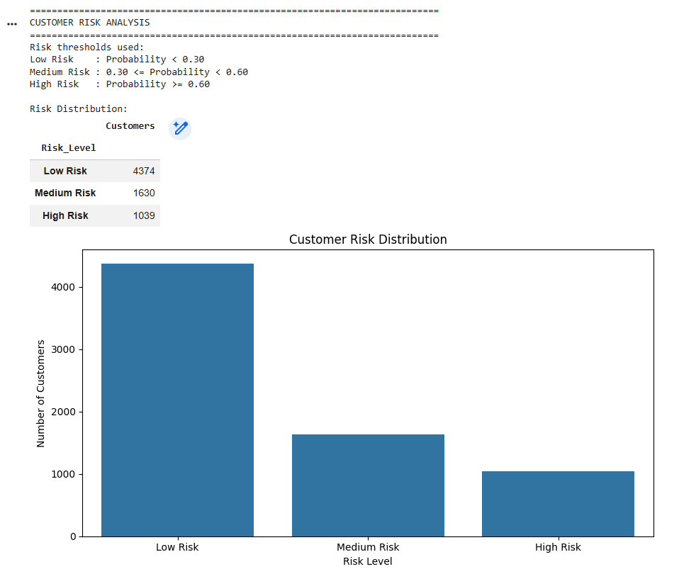


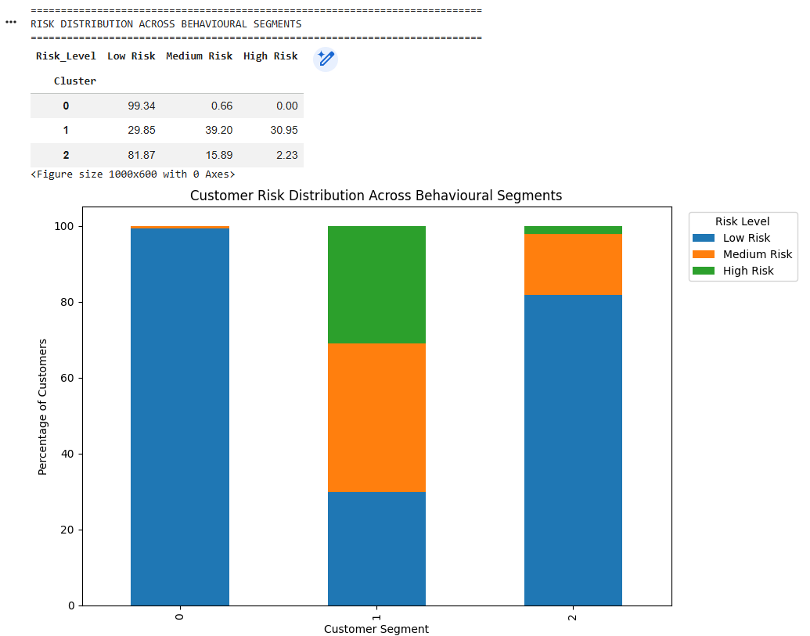
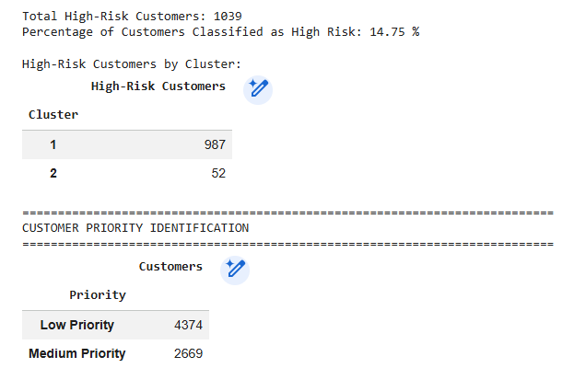
RETENTION RECOMMENDATIONS
The final recommendations should be derived from the actual characteristics of the identified customer segments.
High-Risk New Customers
Recommended actions:
- Strengthen onboarding.
- Provide early engagement support.
- Offer introductory incentives.
High-Charge Customers
Recommended actions:
- Provide personalized service plans.
- Introduce suitable bundled packages.
- Review pricing-related concerns.
Low-Engagement Customers
Recommended actions:
- Send targeted engagement campaigns.
- Promote relevant services.
- Provide personalized service assistance.
Loyal Customers
Recommended actions:
- Provide loyalty benefits.
- Offer personalized upgrades.
- Maintain consistent customer engagement.
These recommendations are decision-support suggestions rather than predictions generated directly by the ML models.
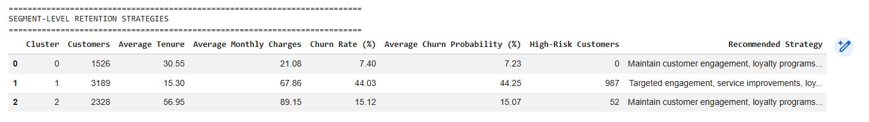

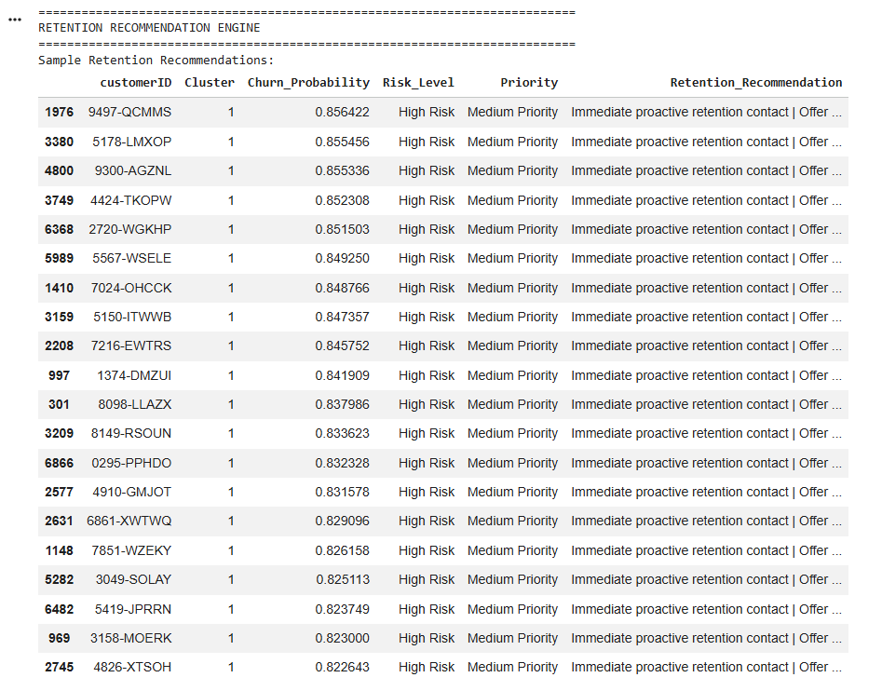
IMPLEMENTATION
The implementation is developed using Python and standard machine learning libraries.
Major Libraries
Python
Pandas
NumPy
Scikit-learn
Matplotlib
Seaborn
If an interactive application is developed:
Streamlit
can be used for the interface.
Implementation Components
The implementation contains separate logical components for:
- Dataset loading
- Data validation
- Preprocessing
- Exploratory analysis
- Feature transformation
- Model training
- Model evaluation
- Hyperparameter experimentation
- K-Means clustering
- Cluster evaluation
- PCA
- Visualization
- Risk prediction
- Retention recommendations
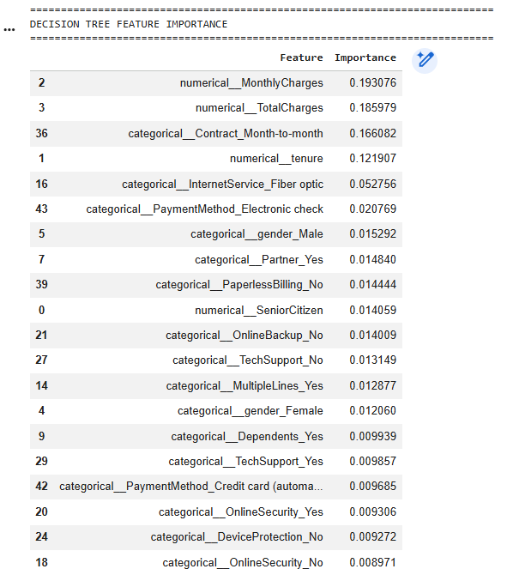
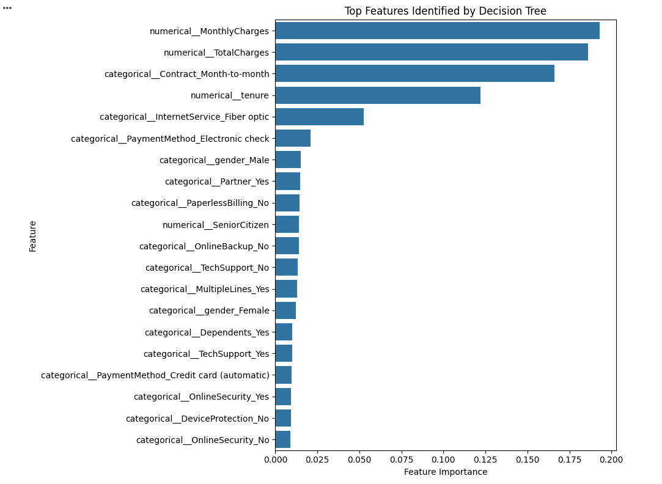
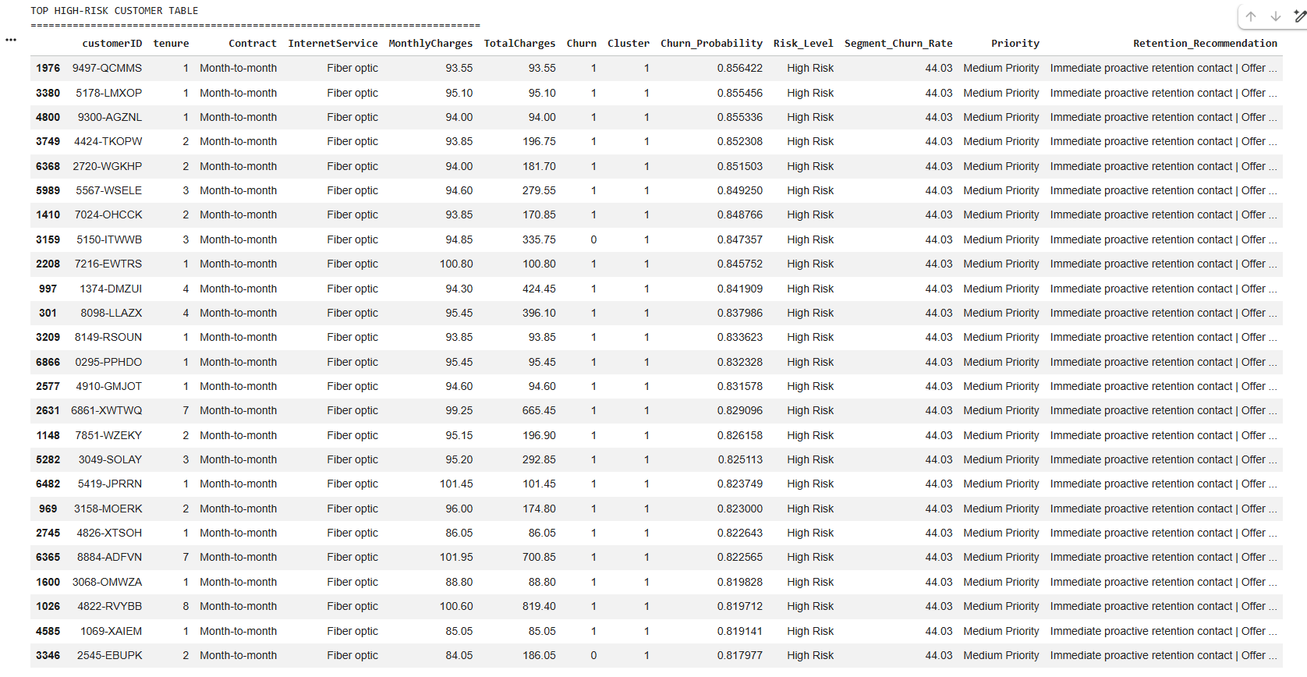
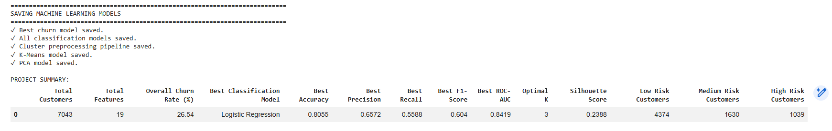

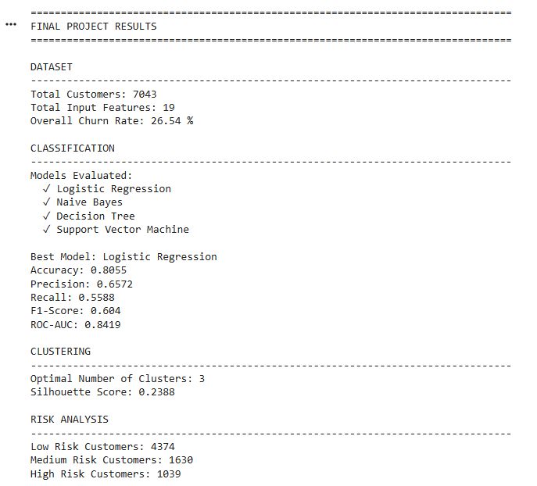
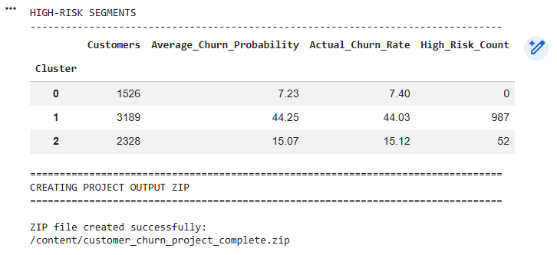
IMPORTANT IMPLEMENTATION OUTPUTS
The following outputs should be generated and captured as screenshots for the report:
- Dataset preview
- Dataset dimensions
- Missing-value analysis
- Preprocessing output
- Churn distribution
- Important EDA visualizations
- Model training output
- Model performance comparison
- Confusion matrices
- ROC curves, if implemented
- Hyperparameter comparison
- Elbow Method graph
- Silhouette score comparison
- K-Means cluster distribution
- PCA cluster visualization
- Cluster characteristics
- Churn rate by cluster
- Customer risk prediction
- Final application/dashboard
These screenshots provide evidence that the implementation was actually executed.
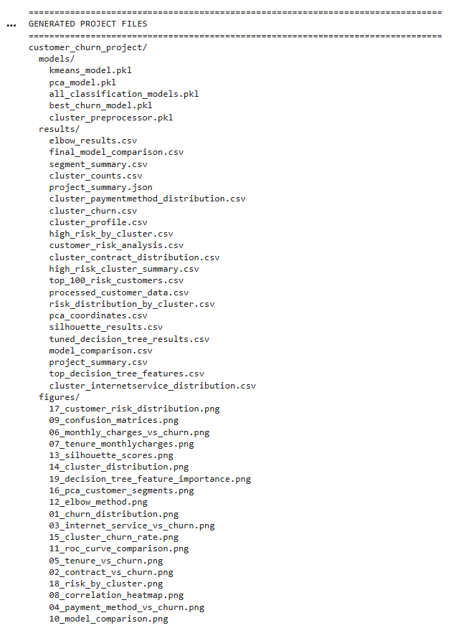
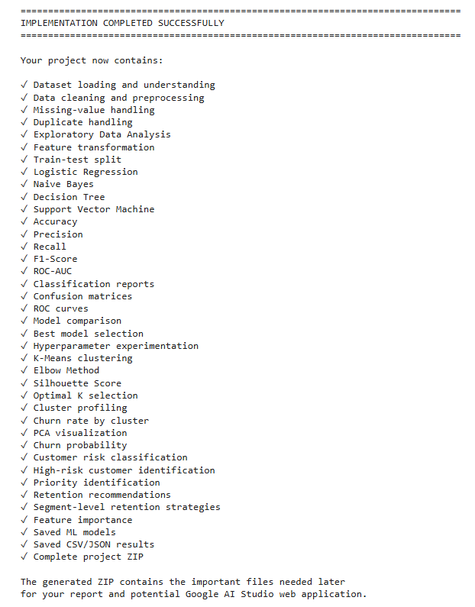
IMPLEMENTATION TESTING
The completed implementation should be tested from beginning to end to ensure that all components operate correctly.
Test Case | Testing Objective | Expected Result
Dataset Loading | Verify dataset can be loaded | Dataset displayed successfully
Data Preprocessing | Verify missing values and categorical data are handled | Clean feature matrix generated
Model Training | Verify all selected models train successfully | Models trained without errors
Prediction | Verify unseen customer data can be classified | Churn prediction generated
Evaluation | Verify metrics are calculated | Performance metrics displayed
K-Means | Verify clustering works | Customer clusters generated
PCA | Verify dimensionality reduction | 2D visualization generated
Risk Analysis | Verify probability-based risk assignment | Risk category generated
Recommendation | Verify segment-based recommendation | Retention action displayed
Complete Execution | Verify complete workflow | Project executes from beginning to end
The assignment specifically states that the implementation should be executable from beginning to end without errors.
RESULTS AND DISCUSSION
The final results should discuss both classification and clustering outcomes.
The classification results should identify which supervised learning model provides the most suitable performance according to the selected evaluation criteria.
The clustering results should explain the characteristics of the identified customer groups.
The relationship between clusters and churn should then be examined to identify customer segments requiring greater attention.
The most important result of the project is therefore not simply the classification accuracy. It is the ability to transform customer data into actionable information:
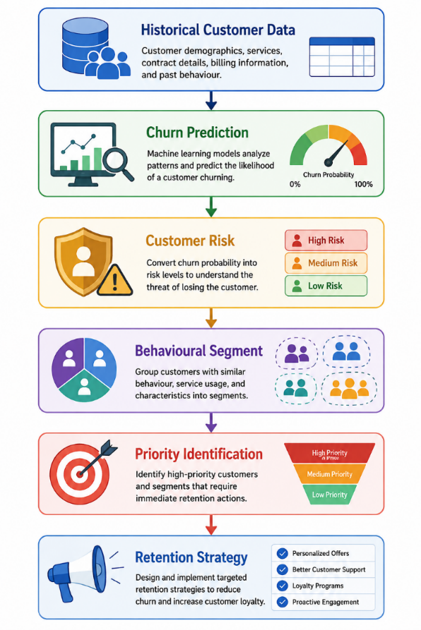
FINAL OBSERVATIONS
The following observations should be finalized after inserting the actual experimental results:
- Customer churn is influenced by multiple demographic, service, contractual and billing-related characteristics rather than a single variable.
- Data preprocessing plays an important role because the dataset contains categorical variables, numerical attributes and potentially inconsistent values.
- Different supervised learning algorithms produce different levels of classification performance.
- Accuracy alone may not be sufficient for evaluating a churn prediction system because the ability to identify actual churners is particularly important.
- K-Means clustering provides an additional perspective by identifying groups of customers with similar characteristics.
- PCA provides a useful visual representation of customer clusters in reduced-dimensional space.
- Some customer segments may demonstrate higher churn rates than others.
- Combining churn probability with customer segmentation provides more useful information for targeted retention planning.
- The final system can help organizations prioritize retention efforts toward customers and customer groups with greater churn risk.
CONCLUSION
The proposed Intelligent Customer Churn Risk Prediction and Behavioural Segmentation System demonstrates a complete machine learning workflow for analyzing customer attrition.
The system performs data preprocessing and exploratory analysis before applying multiple supervised learning algorithms for churn prediction. The implemented models are evaluated using accuracy, precision, recall, F1-score and confusion matrices, allowing their performance to be compared objectively.
K-Means clustering is then applied to discover customer groups based on behavioural and service-related characteristics. The Elbow Method and Silhouette Score can be used to support the selection of an appropriate number of clusters, while PCA provides a visual representation of the resulting segments.
The integration of churn prediction and customer segmentation provides a more practical approach than using classification alone. It allows the system to identify not only customers who may churn, but also the type of customer they represent and the broader customer segments requiring attention.
The final outcome is a machine-learning-based decision-support framework that can assist service organizations in identifying high-risk customers, understanding customer behaviour and developing more targeted retention strategies.
FUTURE SCOPE
Real-Time Churn Monitoring
- Integrate continuously updated customer activity and service data.
- Generate dynamic churn-risk estimates as customer behaviour changes.
Explainable Machine Learning
- Integrate techniques such as SHAP or LIME.
- Explain the major factors contributing to individual churn predictions.
Advanced Segmentation
- Compare K-Means with alternative clustering techniques.
- Investigate whether different algorithms reveal additional customer behaviour patterns.
Cost-Aware Retention
- Incorporate the financial cost of retention campaigns.
- Prioritize interventions based on expected business benefit.
Automated Retention Optimization
- Develop personalized intervention recommendations.
- Evaluate the effectiveness of different retention strategies over time.
REFERENCES
- Amin, A., Al-Obeidat, F., Shah, B., Adnan, A., Loo, J., & Anwar, S. (2019). Customer churn prediction in telecommunication industry using data certainty. Journal of Business Research, 94, 290–301.
- BlastChar. (2018). Telco customer churn [Data set].
- Huang, B., Kechadi, M. T., & Buckley, B. (2012). Customer churn prediction in telecommunications. Expert Systems with Applications, 39(1), 1414–1425.
- IBM. (n.d.). Telco customer churn.
- McKinney, W. (2022). Python for data analysis: Data wrangling with pandas, NumPy, and Jupyter (3rd ed.).
- Pedregosa, F., Varoquaux, G., Gramfort, A., Michel, V., Thirion, B., Grisel, O., Blondel, M., Prettenhofer, P., Weiss, R., Dubourg, V., Vanderplas, J., Passos, A., Cournapeau, D., Brucher, M., Perrot, M., & Duchesnay, É. (2011). Scikit-learn: Machine learning in Python. Journal of Machine Learning Research, 12, 2825–2830.
- Waskom, M. (2021). Seaborn: Statistical data visualization. Journal of Open Source Software, 6(60), 3021.
- Wagh, S. K., Andhale, A. A., Wagh, K. S., Pansare, J. R., Ambadekar, S. P., & Gawande, S. H. (2024). Customer churn prediction in telecom sector using machine learning techniques. Results in Control and Optimization, 14, 100342.
- Poudel, S. S., Pokharel, S., & Timilsina, M. (2024). Explaining customer churn prediction in telecom industry using tabular machine learning models.
Individual Contribution
I contributed to the development of the Intelligent Customer Churn Risk Prediction and Behavioural Segmentation System by actively working on the major stages of the project, from understanding the problem and dataset to implementing machine learning models and analysing the results.
My primary contribution was in dataset understanding and preprocessing. I worked with the Telco Customer Churn dataset and examined its attributes, data types, missing values, and target variable. I helped identify irrelevant attributes such as customerID, converted TotalCharges into a suitable numerical format, handled missing values, encoded categorical variables, and prepared the data for machine learning. I also ensured that the preprocessing steps were applied consistently to the training and testing data.
I also contributed to the Exploratory Data Analysis (EDA) stage. I analysed the distribution of churn and studied customer-related characteristics such as tenure, monthly charges, contract type, internet service, and other service-related attributes. The visualizations generated during this stage helped in understanding customer behaviour and identifying factors that could be associated with churn.
A major part of my work involved the implementation and evaluation of supervised machine learning models. I worked with Logistic Regression, Gaussian Naive Bayes, Support Vector Machine (SVM), and Decision Tree models for predicting whether a customer is likely to churn. I evaluated the models using Accuracy, Precision, Recall, F1-Score, ROC-AUC, and Confusion Matrix. Based on the experimental results, Logistic Regression achieved the best overall F1-score of 0.6040 and ROC-AUC of 0.8419, making it the selected classification model for the system.
I further contributed to Decision Tree hyperparameter experimentation using GridSearchCV. The best configuration obtained a maximum depth of 5 and was evaluated on the test set to compare its performance with the other classification models. This helped demonstrate that model selection should be based on multiple evaluation metrics rather than accuracy alone.
I also worked on the customer segmentation component using K-Means clustering. I experimented with different numbers of clusters using the Elbow Method and Silhouette Score and selected three meaningful customer groups. I analysed the clusters based on customer count, average tenure, monthly charges, and churn rate. The analysis showed that the short-tenure, higher-charge customer segment had the highest churn rate and therefore represents an important group for targeted retention strategies.
Another contribution was the use of PCA for visualization of the customer segments. PCA helped reduce the dimensionality of the prepared customer data into two principal components so that the clustering structure could be visually interpreted.
I also contributed to the integration of prediction and segmentation results by developing the concept of customer churn-risk levels such as Low, Medium, and High Risk. The system combines predicted churn probability with behavioural segment information to identify customers who may require greater retention attention. I helped formulate suitable retention recommendations based on characteristics such as tenure, contract type, monthly charges, and customer service usage.
Finally, I contributed to the overall project documentation and presentation of results, including preparing workflow descriptions, pseudocode, methodology, model comparison, cluster interpretation, visualizations, observations, conclusion, and report content. I also worked on organizing the implementation so that the complete workflow can be executed in Google Colab from data loading and preprocessing through model training, clustering, visualization, evaluation, and generation of final results.
Overall, my contribution covered the core technical and analytical stages of the project, particularly data preprocessing, exploratory analysis, supervised machine learning, model evaluation and tuning, K-Means segmentation, PCA visualization, churn-risk analysis, retention recommendations, and documentation of the complete system.

